**JSS MAHAVIDYAPEETHA**

**JSS SCIENCE AND TECHNOLOGY UNIVERSITY**

JSS Technical Institutions Campus, Mysuru – 570006



**CERTIFICATE**

This is to certify that the work entitled “**UNIFIED FOOD DELIVERY OPERATIONS**” is a bonafied work carried out by, **Prashanth M**, **M V Nagavardhan Vasist**, and **Sharath HK** in partial fulfillment of the award of the degree of **Bachelor of Engineering in Computer Science and Engineering of JSS Science and Technology, Mysuru during the year 2025**. It is certified that all corrections / suggestions indicated during CIE have been incorporated in the report. The mini project report has been approved as it satisfies the academic requirements in respect of mini project work for Event 1 prescribed for the **WEB TECHNOLOGY**(20CS620) course.

## Course in Charge and Guide

**Prof.Vaishnavi**

### **Assistant Professor,**

### **Department of Computer Science And Engineering,**

### **JSS STU, Mysuru.**

**Place:** MYSURU

**Date : 18 April 2024**

**CONTENTS**

1. **ABSTRACT 3**
2. **INTRODUCTION 4**
3. **OBJECTIVES 5**
4. **SOFTWARE REQUIREMENTS 7**
5. **HARDWARE REQUIREMENTS 8**
6. **METHODOLOGY 9**
7. **FLOW GRAPHS 11**
8. **FRONT END USER INTERFACE 12**
9. **CONCLUSION 19**
10. **REFERENCES 20**

**ABSTRACT**

* This project outlines the development of a unified food delivery operations platform aimed at optimizing efficiency and enhancing user experience within the food delivery industry. With the proliferation of food delivery services, there is a growing need for a cohesive platform that integrates various stakeholders and streamlines the delivery process.
* The primary objective of this endeavor is to design and implement a centralized platform that connects restaurants, delivery drivers, and customers seamlessly. To achieve this, comprehensive research will be conducted to understand the needs, pain points, and preferences of all stakeholders involved. Through surveys, interviews, and competitor analysis, insights will be gleaned to inform the platform's design and functionalities.
* Key features of the platform will include a user-friendly interface for restaurants to manage orders, track inventory, and update menus in real-time. Delivery drivers will have access to a dedicated app for efficient route planning, order assignment, and communication with customers. Customers, on the other hand, will benefit from a user-centric interface for browsing menus, placing orders, and tracking deliveries in real-time.
* Technologically, the platform will leverage modern web and mobile development frameworks to ensure scalability, reliability, and responsiveness across devices. Back-end operations will be powered by robust server-side technologies capable of handling high volumes of transactions and data.
* Throughout the development process, rigorous testing procedures will be employed to ensure the platform's functionality, security, and user experience meet industry standards. This will include unit testing, integration testing, and user acceptance testing to identify and address any potential issues before deployment.
* In conclusion, the development of a unified food delivery operations platform holds immense potential to revolutionize the food delivery industry by streamlining operations, reducing costs, and enhancing user satisfaction. By bringing together restaurants, delivery drivers, and customers on a single platform, we aim to create a more efficient and seamless delivery experience for all stakeholders involved.

**INTRODUCTION**

* In the rapidly evolving landscape of the food industry, the emergence of food delivery services has revolutionized the way people experience dining. With the convenience of ordering meals from a plethora of restaurants at their fingertips, consumers now expect seamless and efficient delivery experiences. However, behind this seemingly simple process lies a complex network of operations that require meticulous coordination and integration.
* This project report delves into the realm of unified food delivery operations, aiming to explore the intricacies involved in streamlining and optimizing the entire delivery process. By "unified," we refer to the harmonization of various components within the food delivery ecosystem, including logistics, technology platforms, and customer service, to deliver a cohesive and consistent experience for both customers and stakeholders.

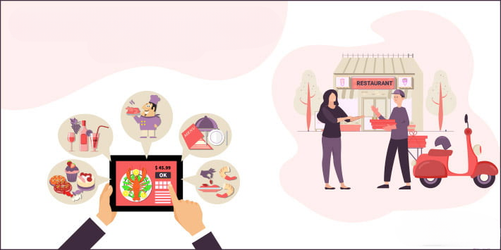

* The significance of this study lies in its potential to unveil insights and best practices that can enhance the efficiency, reliability, and sustainability of food delivery operations. As the demand for food delivery continues to soar, understanding how to effectively manage and coordinate these operations becomes increasingly crucial for businesses to thrive in this competitive landscape.
* Throughout this report, we will examine the key elements of unified food delivery operations, including technological innovations, logistical challenges, customer satisfaction metrics, and strategies for overcoming barriers to efficiency. By analyzing real-world case studies and industry trends, we aim to provide valuable insights and recommendations for businesses looking to optimize their food delivery operations and stay ahead in an ever-evolving market.
* **Significance of the Study:** 
  + The significance of this study lies in its potential to uncover insights and best practices that can enhance the efficiency, reliability, and sustainability of food delivery operations. As the demand for food delivery services continues to soar, businesses face mounting pressure to optimize their operations and differentiate themselves in an increasingly competitive landscape.

**OBJECTIVES**

* **Enhance Operational Efficiency:**
  + Streamline the end-to-end delivery process to optimize resource utilization, minimize delivery times, and reduce operational costs.
* **Improve Delivery Reliability:**
  + Ensure timely and reliable delivery of orders by implementing robust logistics systems, efficient route planning, and proactive communication with customers.
* **Enhance Customer Experience**
  + Prioritize customer satisfaction by focusing on order accuracy, food quality, delivery speed, and responsiveness to customer inquiries and feedback.
* **Optimize Last-Mile Delivery:**
  + Address the challenges associated with last-mile delivery, such as traffic congestion, delivery location accuracy, and variable demand patterns, to improve delivery efficiency and customer satisfaction.
* **Leverage Technology Solutions:**
  + Harness the power of technology to automate processes, facilitate real-time tracking and monitoring, and provide personalized experiences for both customers and delivery personnel.
* **Ensure Food Safety and Quality**
  + Implement rigorous quality control measures throughout the delivery process to uphold food safety standards and ensure that delivered meals meet the expected quality standards.
* **Sustainably Manage Operations:**
  + Minimize environmental impact by optimizing delivery routes, reducing packaging waste, and exploring eco-friendly transportation options, contributing to sustainable business practices.
* **Foster Collaboration and Partnerships:**
  + Forge strategic partnerships with restaurants, delivery drivers, technology providers, and other stakeholders to create a unified ecosystem that maximizes efficiency and benefits all parties involved.
* **Adapt to Changing Market Dynamics:**
  + Stay agile and responsive to evolving consumer preferences, market trends, and regulatory requirements, adjusting strategies and operations accordingly to maintain competitiveness.
* **Measure and Improve Performance:**
  + Continuously monitor key performance indicators (KPIs) such as delivery times, customer satisfaction scores, and delivery accuracy rates, using data-driven insights to identify areas for improvement and drive operational excellence.

.

**SOFTWARE REQUIREMENTS**

**1. HTML/CSS:**

* + Design user interfaces for various pages using HTML for structure and CSS for styling.
  + Ensure responsive design for different devices.

**2. PHP:**

* + Use PHP for server-side scripting to handle form submissions, database interactions, and other server-side logic.
  + Implement functions for user authentication, data validation, and processing.

**3. SQL:**

* + Write SQL queries for creating and managing the database.
  + Use prepared statements to prevent SQL injection.

**4. INTEGRATION:**

* + Integrate PHP with HTML forms to handle user input.
  + Connect PHP to the database using MySQLi or PDO for secure database operations.

**5. SECURITY:**

* + Implement security measures such as input validation, output encoding, and parameterized queries to prevent common security vulnerabilities.

**6. TESTING:**

* + Conduct thorough testing of the system to identify and fix bugs.
  + Perform security testing to ensure the system is robust against potential threats.

**7. DEPLOYMENT:**

* + Deploy the system on a web server.
  + Configure server settings and ensure the system is accessible to users.

**HARDWARE REQUIREMENTS**

* + **WEB SERVER:**
    - High-performance servers with multi-core processors (e.g., Intel Xeon or AMD EPYC), ample RAM (e.g., 16GB to 32GB), and fast SSD storage to handle concurrent user requests and serve dynamic web content efficiently.
    - Scalable infrastructure with load balancing capabilities to distribute incoming traffic across multiple web servers and ensure high availability and fault tolerance.
  + **DATABASE SERVER:**
    - Dedicated database servers equipped with fast storage (e.g., SSDs or NVMe drives) and sufficient memory to handle database queries and transactions efficiently.
    - Relational database management systems (RDBMS) such as MySQL, PostgreSQL, or SQL Server for storing and managing user data, order information, restaurant menus, and transaction records.
  + **LOAD BALANCER:**
    - Load balancing hardware or software to evenly distribute incoming web traffic among multiple web servers, preventing overloading and ensuring optimal performance and responsiveness.
    - Dynamic load balancing algorithms and health checks to monitor server health and adjust traffic routing based on server availability and performance metrics.
  + **NETWORKING EQUIPMENT:**
    - Enterprise-grade routers, switches, and firewalls to provide reliable connectivity, network segmentation, and traffic management for internal communication between servers and external access from users.
    - Secure socket layer (SSL) certificates and encryption protocols to encrypt data transmission between web servers and clients, ensuring data privacy and security.
  + **BACKUP AND DISASTER RECOVERY:**
    - Automated backup solutions for regular backups of website data, configuration files, and databases to prevent data loss and facilitate quick recovery in the event of hardware failures, data corruption, or cyber-attacks.
    - Off-site backup storage or cloud-based backup services for redundant data storage and disaster recovery preparedness.
  + **MONITORING AND MANAGEMENT TOOLS:**
    - Network monitoring software and server management platforms for real-time monitoring of server performance, resource utilization, and network traffic.
    - Logging and alerting mechanisms to detect and respond to potential issues, such as server failures, performance degradation, or security breaches, in a timely manner.

**METHODOLOGY**

* + **REQUIREMENT ANALYSIS:**
    - Begin by conducting a comprehensive analysis of the requirements for unified food delivery operations. Understand the target market demographics, customer preferences, and the specific features needed to facilitate seamless ordering, delivery, and customer service.
    - Gather insights from market research, competitor analysis, and stakeholder consultations to identify key functionalities such as order management, delivery tracking, inventory management, and customer feedback mechanisms.
  + **PLANNING:**
    - Develop a detailed project plan outlining the scope, objectives, timelines, and resource requirements for implementing unified food delivery operations.
    - Allocate resources such as manpower, technology infrastructure, and budget for various stages of the project, including development, testing, deployment, and ongoing maintenance.
    - Decide on the technology stack, including software platforms, programming languages, frameworks, and third-party integrations needed to support the delivery ecosystem effectively.
  + **DESIGN:**
    - Design the architecture and workflow of the unified food delivery system, including the user interface (UI) and user experience (UX) design for both customers and delivery personnel.
    - Create wireframes, mockups, and prototypes to visualize the layout, navigation flow, and interaction patterns of the delivery platform.
    - Incorporate design principles such as simplicity, intuitiveness, and accessibility to ensure a seamless and engaging user experience across web and mobile interfaces.
  + **DEVELOPMENT:**
    - Start with front-end development to implement the visual design, navigation elements, and interactive features of the food delivery platform using HTML, CSS, and JavaScript.
    - Proceed with back-end development to build the server-side logic, database schema, and application programming interfaces (APIs) necessary to support core functionalities such as order processing, inventory management, and user authentication.
    - Integrate third-party services and APIs for payment processing, geolocation tracking, SMS notifications, and other essential features to enhance the functionality and user experience of the delivery platform.
  + **TESTING:**
    - Conduct rigorous testing of the unified food delivery system to ensure reliability, security, and performance across various devices, browsers, and network conditions.
    - Perform unit testing to validate the functionality of individual components, integration testing to verify the interaction between different modules, and end-to-end testing to simulate real-world user scenarios.
    - Consider user acceptance testing (UAT) to gather feedback from stakeholders, including customers, restaurant partners, and delivery drivers, and incorporate necessary improvements before deployment.
  + **DEPLOYMENT:**
    - Deploy the unified food delivery system on a scalable and secure hosting environment, ensuring high availability, fault tolerance, and optimal performance.
    - Configure domain settings, SSL certificates, and server-side caching to enhance security and improve website loading speeds.
    - Monitor the deployment process closely to address any issues or errors promptly and ensure a smooth transition to the production environment.

**FLOW GRAPH**

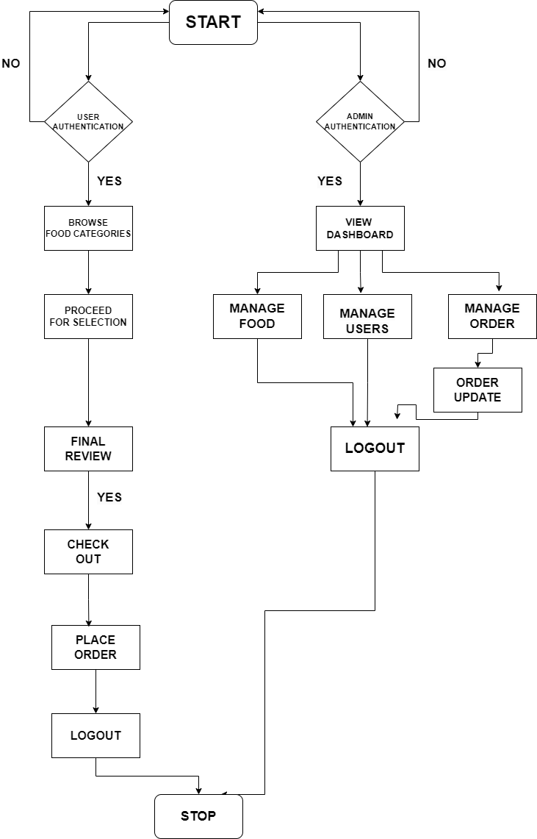

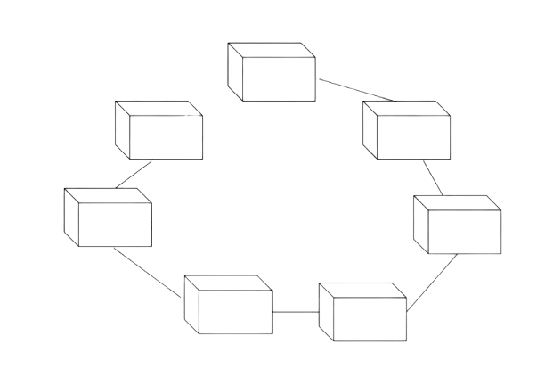

**SEARCH FOOD**

**ORDER**

**PAYMENT**

**STATUS**

**FOOD**

**DELIVERY**

**LOGIN**

**WEBSITE**

**FRONT END USER INTERFACE**

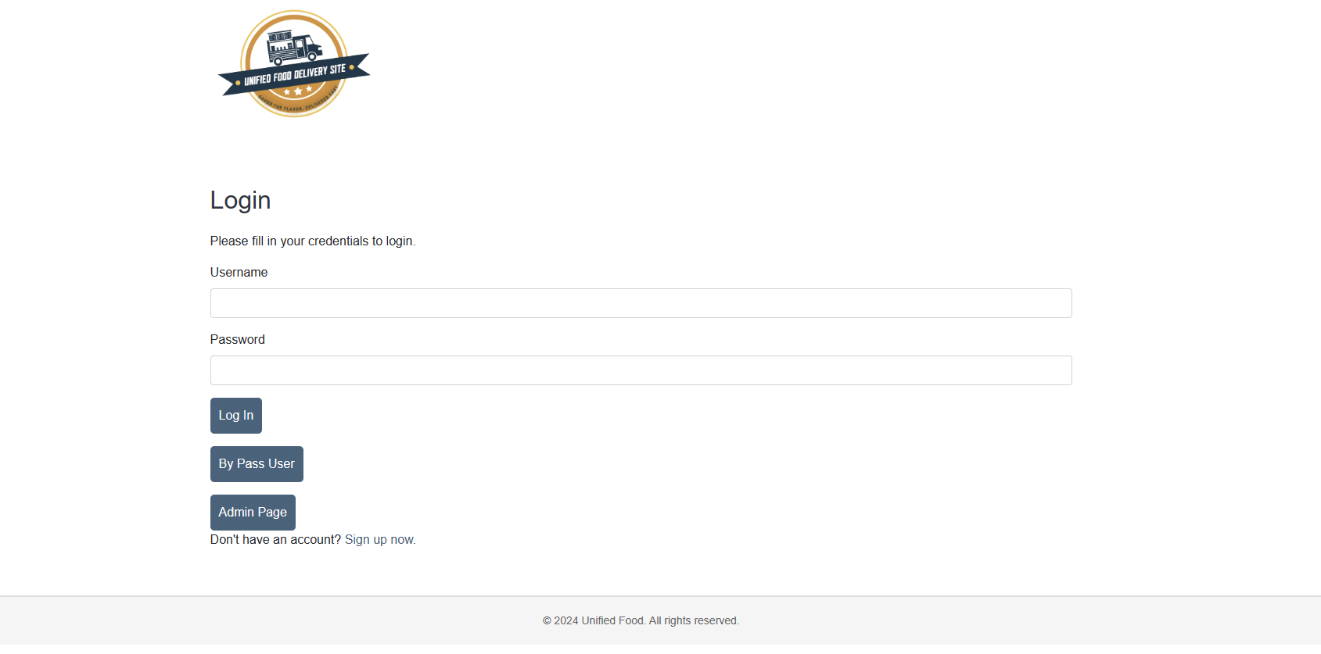

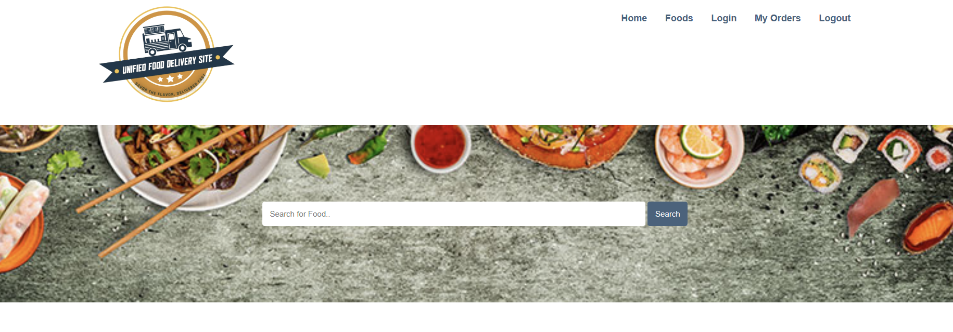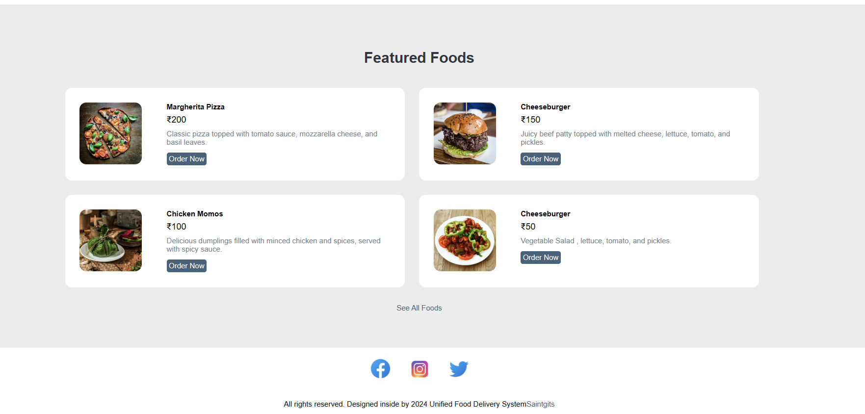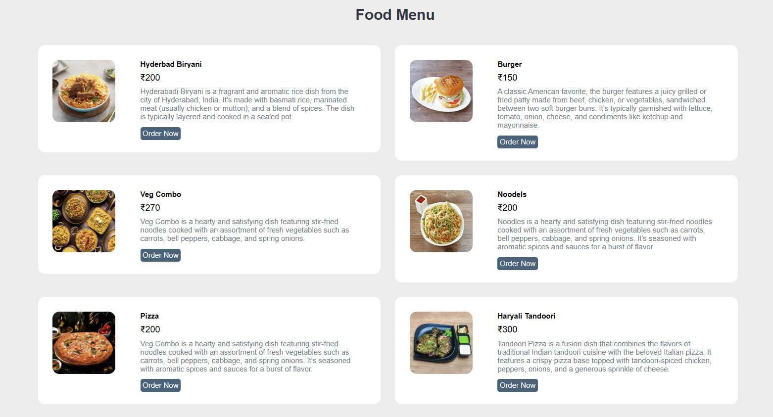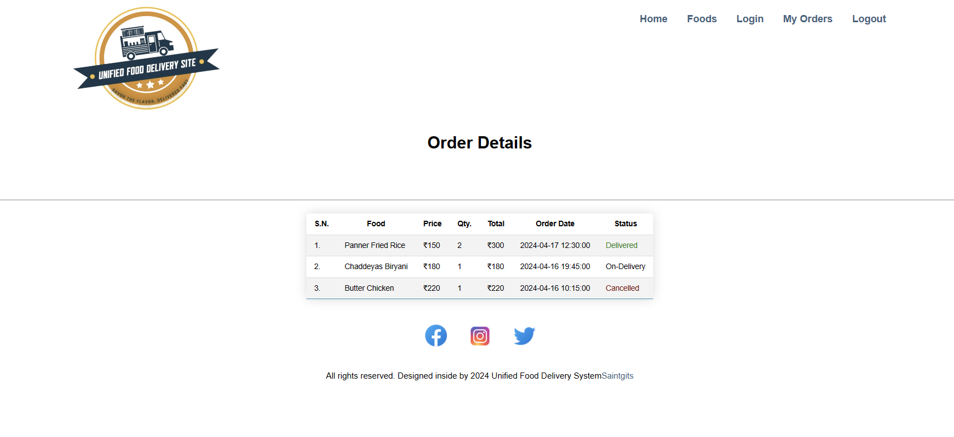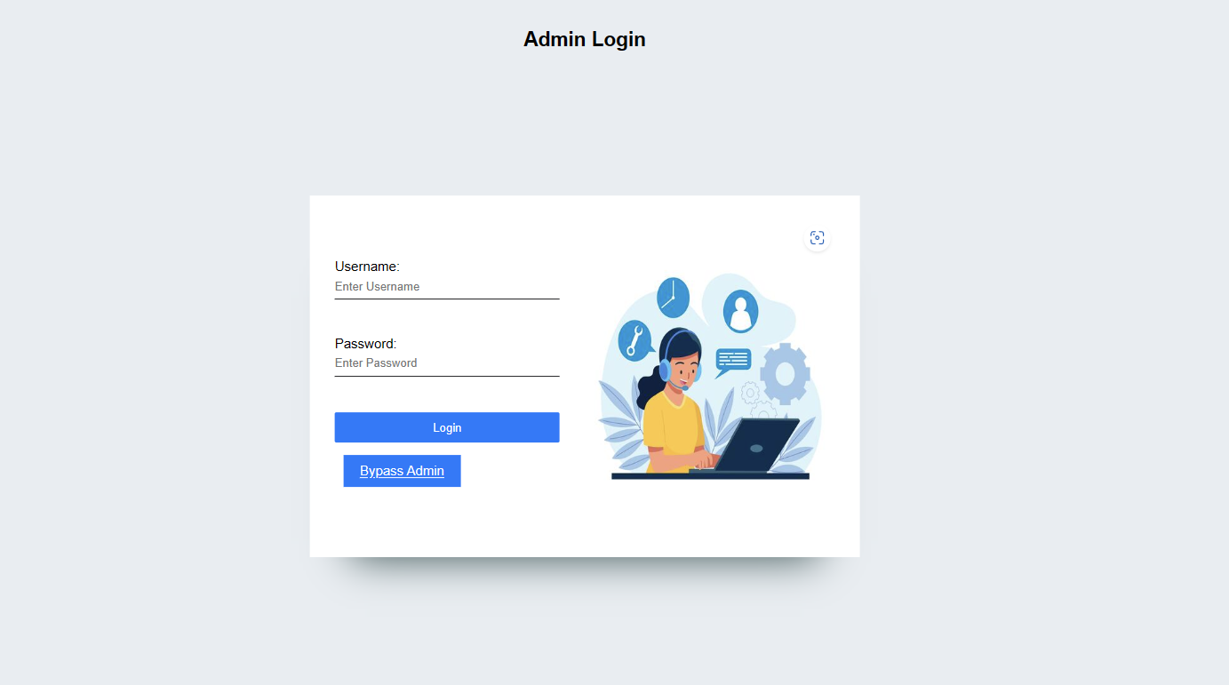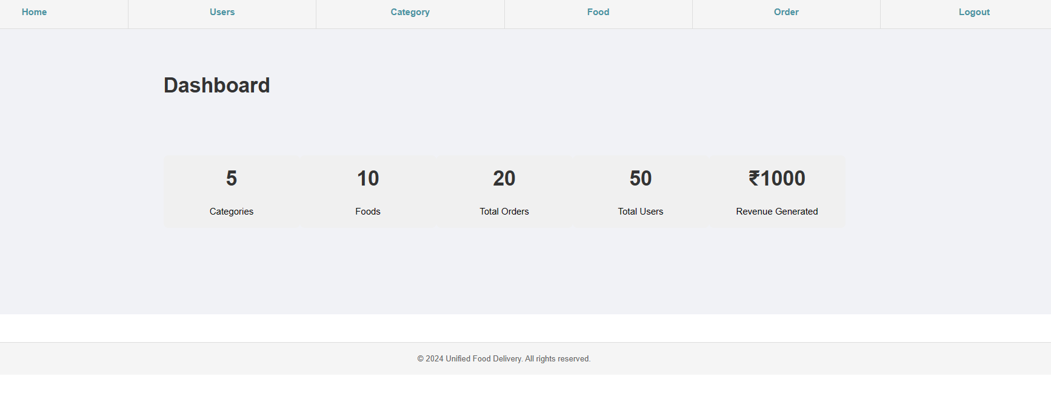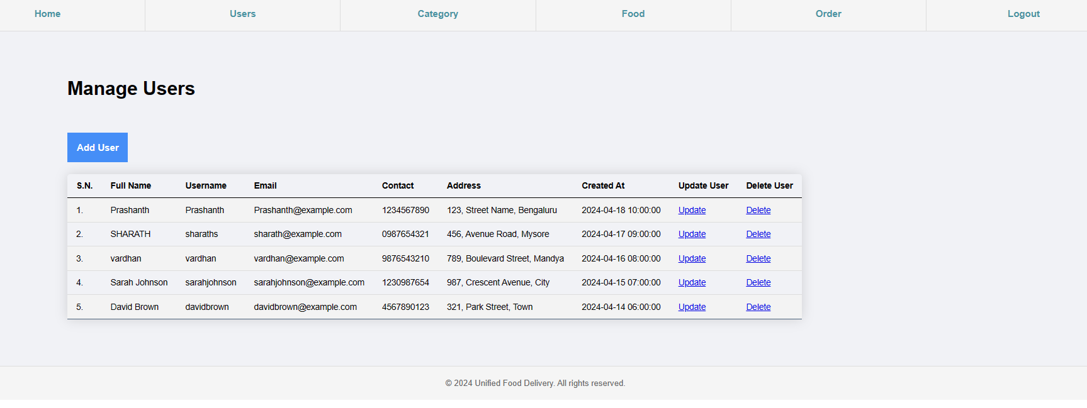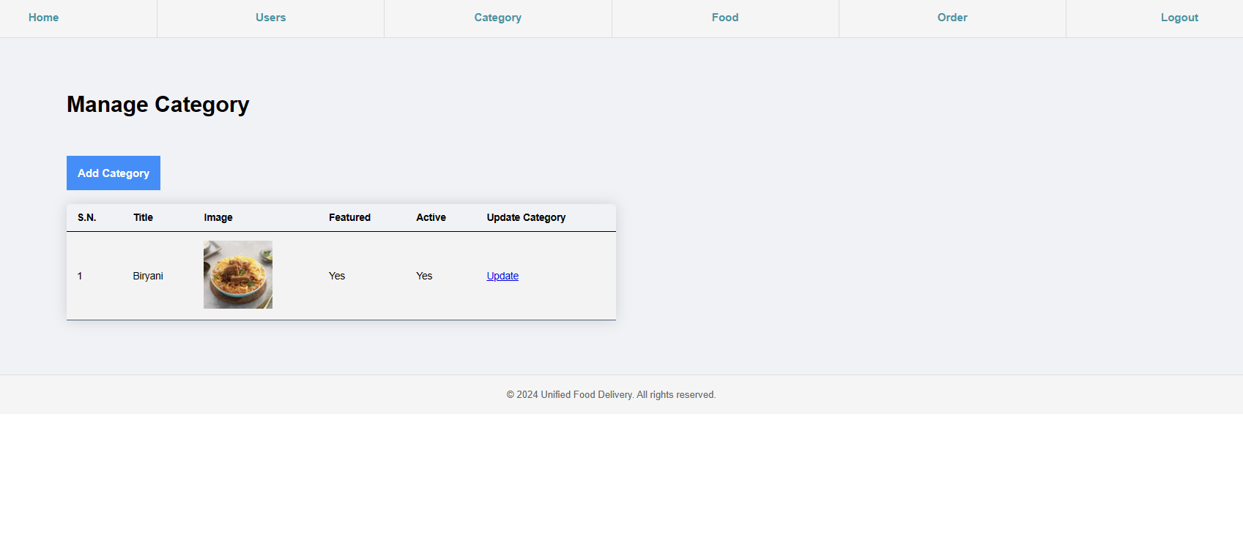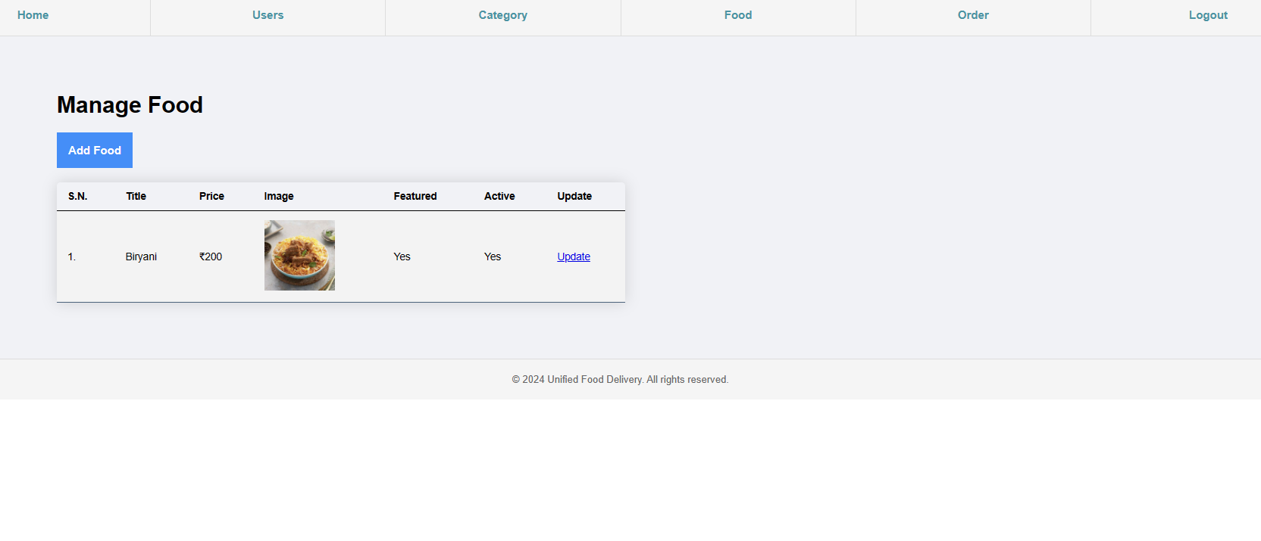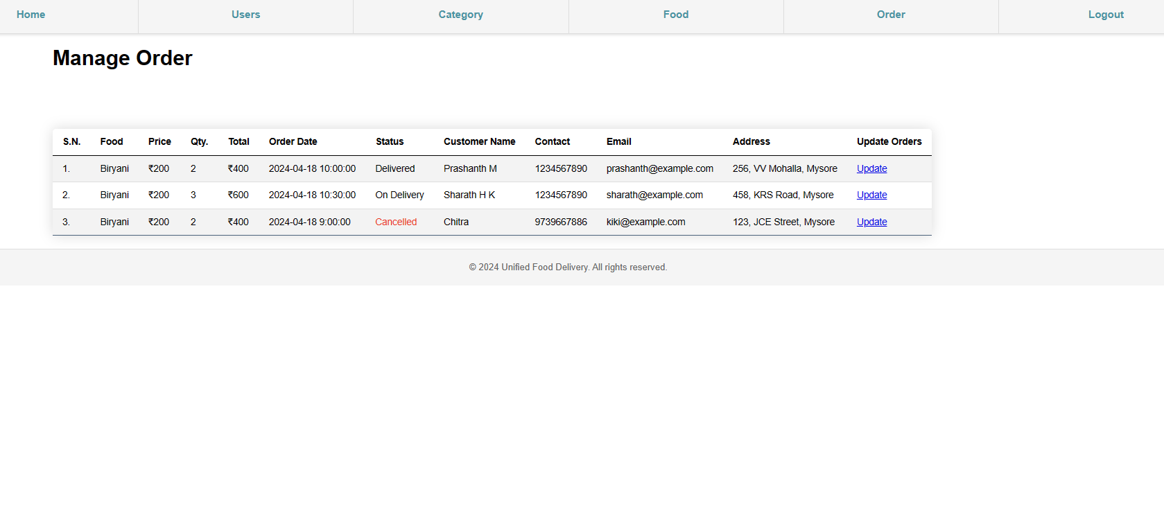

## CONCLUSION

* **STREAMLINED OPERATIONS**
  + The website offers a centralized platform for managing food delivery operations, simplifying the process for both customers and restaurants.
* **ENHANCED USER EXPERIENCE:**
  + Through intuitive design and seamless navigation, users can easily browse menus, place orders, and track deliveries, ensuring a satisfying experience.
* **OPERATIONAL EFFICIENCY:**
  + Leveraging advanced technologies and industry best practices, the website optimizes delivery logistics, reducing errors and improving delivery times.
* **COMPETITIVE ADVANTAGE:** 
  + By staying abreast of industry trends and incorporating insights from market research, the project positions itself as a competitive player in the online food delivery market.
* **CUSTOMER SATISFACTION:**
  + With real-time tracking and responsive customer support, the website prioritizes customer satisfaction, fostering loyalty and positive word-of-mouth.
* **MARKET POTENTIAL:**
  + As the demand for online food delivery continues to grow, the project capitalizes on this market potential, offering a convenient solution for modern-day food delivery needs.

## REFERENCES

* + Namecheap. (2023). "The Ultimate Guide to Website Design and Development." [Online]. Available: [https://www.namecheap.com/guide/website-design-and-development/](https://www.namecheap.com/guide/website-design-and-development/)
  + W3Schools. (n.d.). "HTML Tutorial." [Online]. Available: [https://www.w3schools.com/html/](https://www.w3schools.com/html/)
  + CSS-Tricks. (n.d.). "A Complete Guide to Flexbox." [Online]. Available: [https://css-tricks.com/snippets/css/a-guide-to-flexbox/](https://css-tricks.com/snippets/css/a-guide-to-flexbox/)
  + Adobe XD. (n.d.). "Adobe XD Tutorial: A Beginner's Guide." [Online]. Available: [https://www.adobe.com/products/xd/learn/get-started.html](https://www.adobe.com/products/xd/learn/get-started.html)
  + Nielsen Norman Group. (2022). "10 Usability Heuristics for User Interface Design." [Online]. Available: [https://www.nngroup.com/articles/ten-usability-heuristics/](https://www.nngroup.com/articles/ten-usability-heuristics/)
  + Medium. (2023). "The Difference Between UX And UI Design - A Layman’s Guide." [Online]. Available: [https://uxdesign.cc/the-difference-between-ux-and-ui-design-a-laymans-guide-9a64e84502ee](https://uxdesign.cc/the-difference-between-ux-and-ui-design-a-laymans-guide-9a64e84502ee)
  + Harvard Business Review. (2018). "The Food Delivery War Is Still On." [Online]. Available: [https://hbr.org/2018/11/the-food-delivery-war-is-still-on](https://hbr.org/2018/11/the-food-delivery-war-is-still-on)